Proposal Guide
  - 2024 Course Abroad

Center for International Education

Center for International Education
Central Connecticut State University

Proposal Guide
2024 Course abroad

Table of Contents
INTRODUCTION 3
DEFINITIONS 3
I. SUBMISSION PROCESS/TIMELINE 3
II. CIE’S FINAL APPROVAL 5
III. LEARNING OUTCOMES 5
IV. DEVELOPING A COURSE ABROAD SECTION 6
V. STAFFING, REMUNERATION, AND INDEMNIFICATION 6
VI. COURSE ABROAD SCHEDULING MODELS 6
VII. COURSE LOAD, CONTACT HOURS, AND SYLLABI 7
VIII. MISCELLANEOUS COURSE ABROAD DESIGN AND IMPLEMENTATION PARTICULARS 8
A. PROGRAM ITINERARIES 8
B. FINANCIAL POLICIES 9
C. PARTICIPANTS 9
D. HEALTH, SAFETY, AND EMERGENCY PROCEDURES 10
E. MARKETING AND PROMOTION 10
F. ACCESSIBILITY 10
G. ACCOMMODATION 10
H. ORIENTATION PROGRAMS 11
I. PROGRAM CANCELLATION, WITHDRAWAL, AND TERMINATION 11
J. PLANNING RESOURCES 12
K. CIE STAFF CONTACTS FOR THE COURSE ABROAD PROGRAM: 12

INTRODUCTION

This document includes guidelines that are intended to inform faculty of the regulations that apply to all Courses Abroad, which are offered by academic departments in partnership with the Center for International Education (CIE). Faculty are encouraged to consult with members of CIE Study/Course Abroad unit for further clarification and/or advice.

DEFINITIONS

“Courses Abroad” are intense, short-term, credit-bearing University classes that foster the understanding of world issues, cultural differences, and global interdependencies. “Courses Abroad” are academic courses. They cannot be categorized as sightseeing, touristic, or recreational, although students abroad may have learning experiences that are not typically academic in nature. Students who participate in Course Abroad earn academic credits.

I. SUBMISSION PROCESS/TIMELINE
Any faculty member proposing to teach a Course Abroad section must complete the Course Abroad Proposal Form, attach all necessary materials, obtain the signatures of the appropriate Department Chairperson(s) and, if cross-listing with an International Studies (IS) course credit, the Director(s) of the International Studies Program, prior to submitting a copy of their proposal (and all required attachments) to their Academic Dean.

The Course Abroad submission process/timeline is as follows:

Step 1 | February 10, 2023: Center for International Education issues, via e-mail, two documents: “2024 Course Abroad Proposal Form” AND “Proposal Guide for 2024 Course Abroad”
Step 2 | March 24, 2023: Interested faculty members submit the completed Course Abroad Proposal Form to the appropriate Department Chair(s) and copy to Zongxiang Mei in the Center for International Education (zongxiang.mei@ccsu.edu). When approving the faculty to teach the course(s) listed in the proposal, the department chair also agrees to list the course(s) along with all other regular departmental offerings in the academic semester/session in which the Course Abroad program will occur.
Step 3 | April 7, 2023: If cross-listing with an International Studies (IS) course, the Department Chairs send proposal to the Director(s) of the International Studies (undergrad and/or graduate) for approval before forwarding the copy of approved proposals to their Academic Dean.
Step 4 | April 8-21, 2023: Academic Deans review proposals and request changes, as necessary. The Academic Dean’s approval is contingent upon the Department Chair’s prior approval.
Step 5 | April 21, 2023: Academic Deans forward proposals with graduate-level courses to the Dean of Graduate Studies for his/her review and approval as appropriate. Proposals which offer 500-level coursework will be reviewed and approved by the Dean of Graduate Studies. The Dean of Graduate Studies will also ascertain if the proposed courses should be listed together as one course or if each (e.g. graduate and undergraduate) will need to stand on its own.
Step 6 | May 5, 2023: Academic Deans forward approved proposals (bearing signatures from the applying faculty member, department chair(s) and dean(s)) to CIE (attention: Momar Ndiaye at mndiaye@ccsu.edu).
Step 7 | May – August 2023: CIE develops print and web-based material for all programs.
Step 8 | July 2023 to January 2024: CIE develops program budgets, sets prices, and forecasts scholarships.

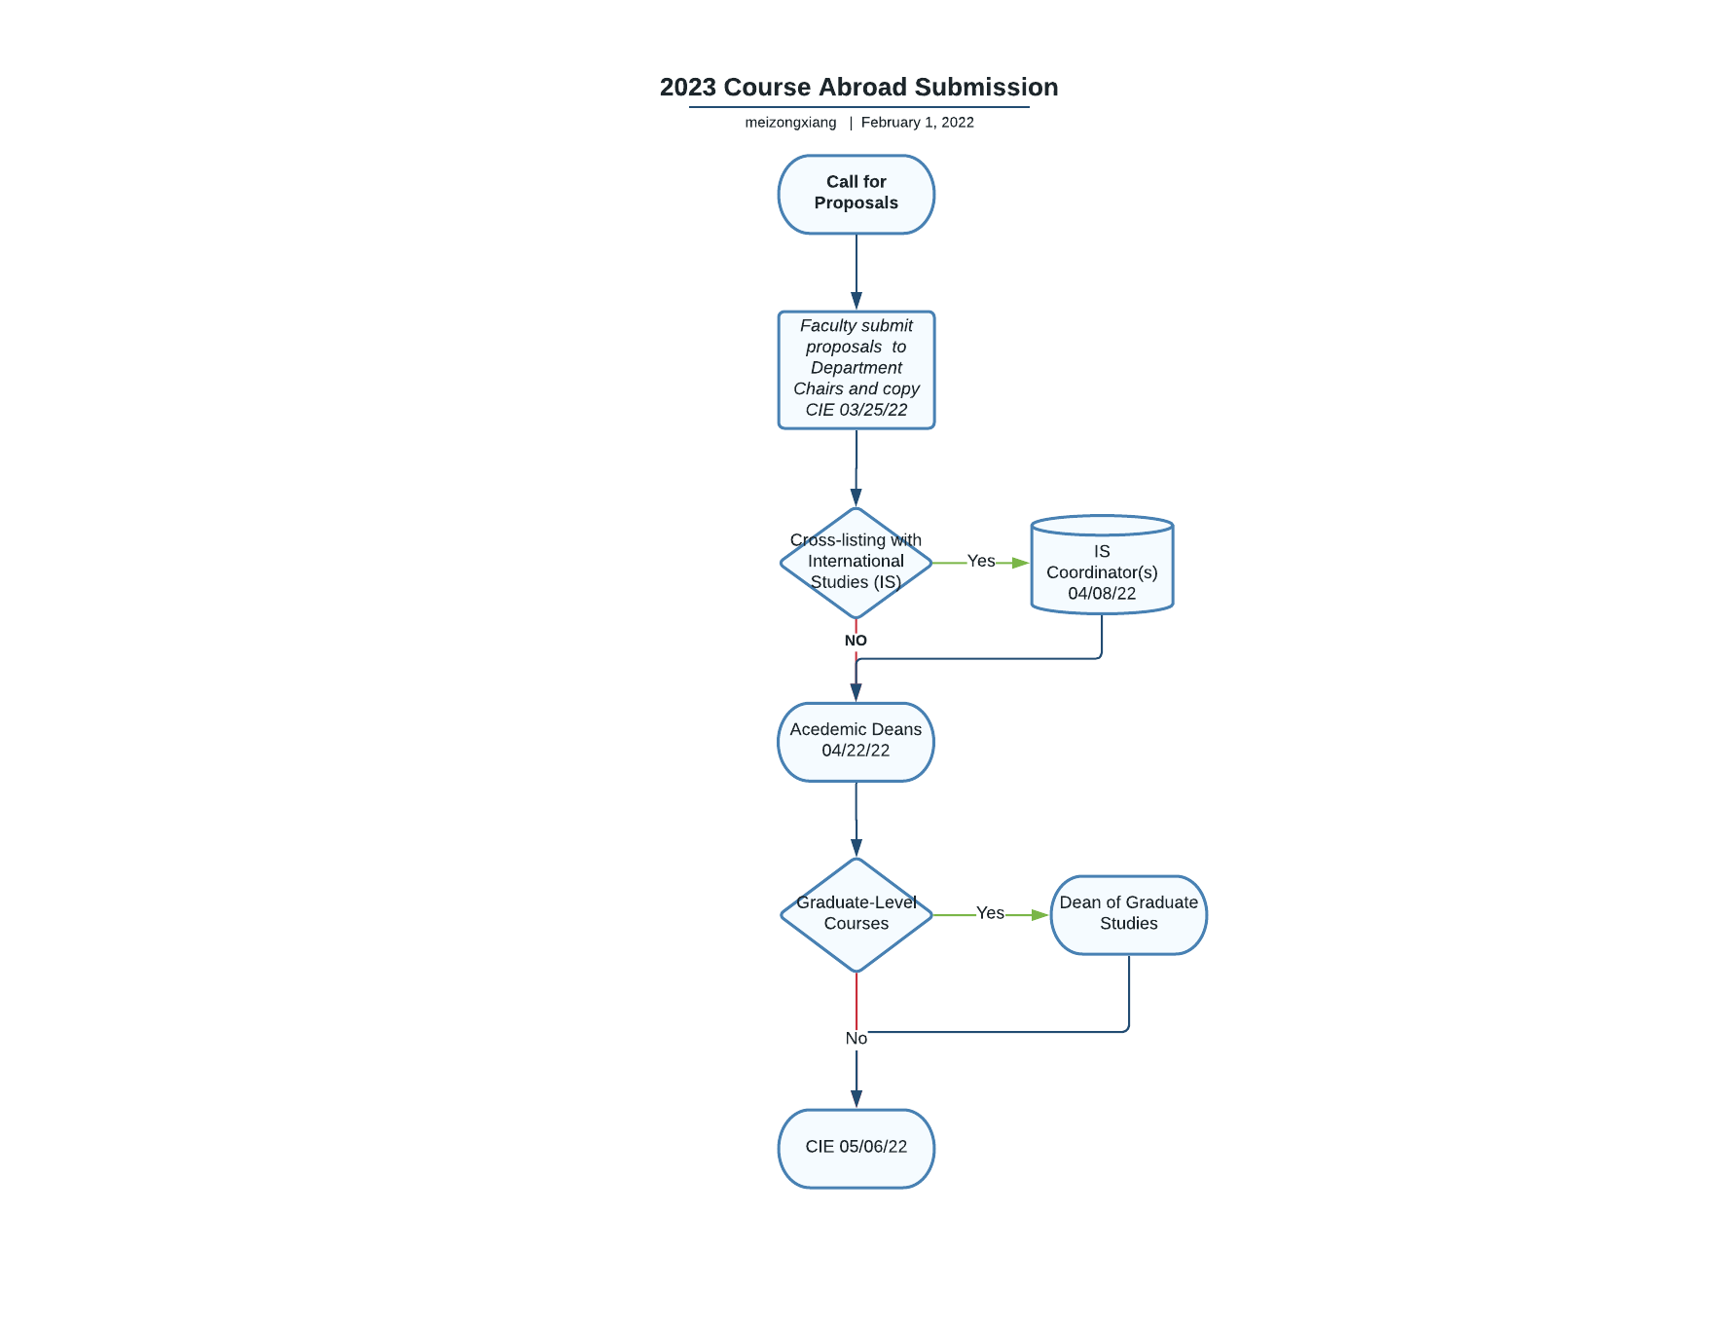

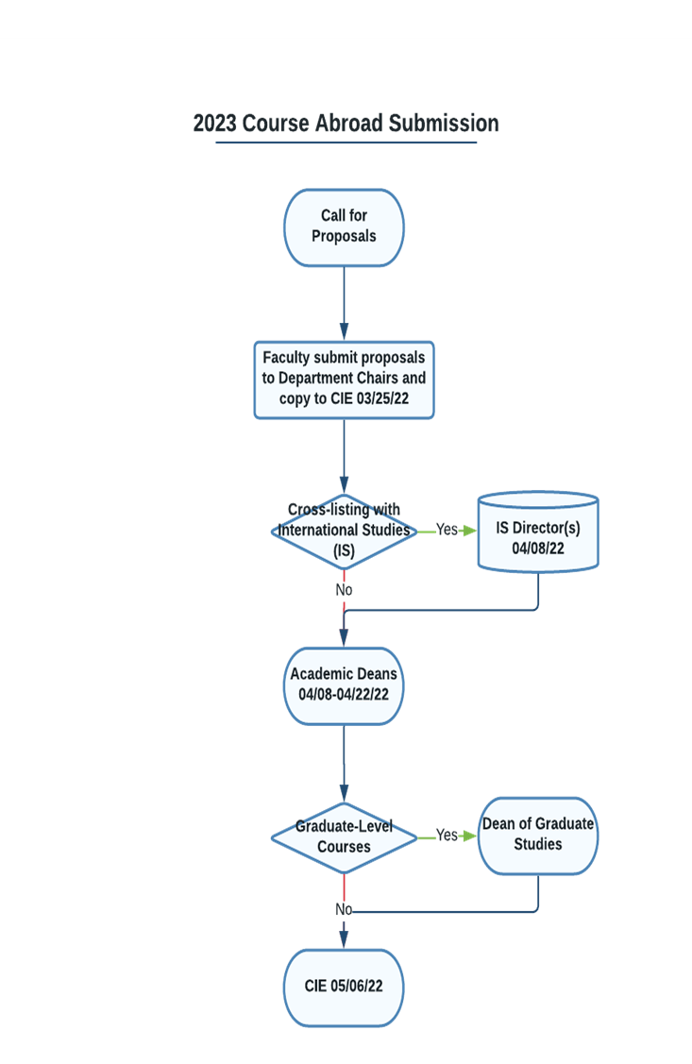
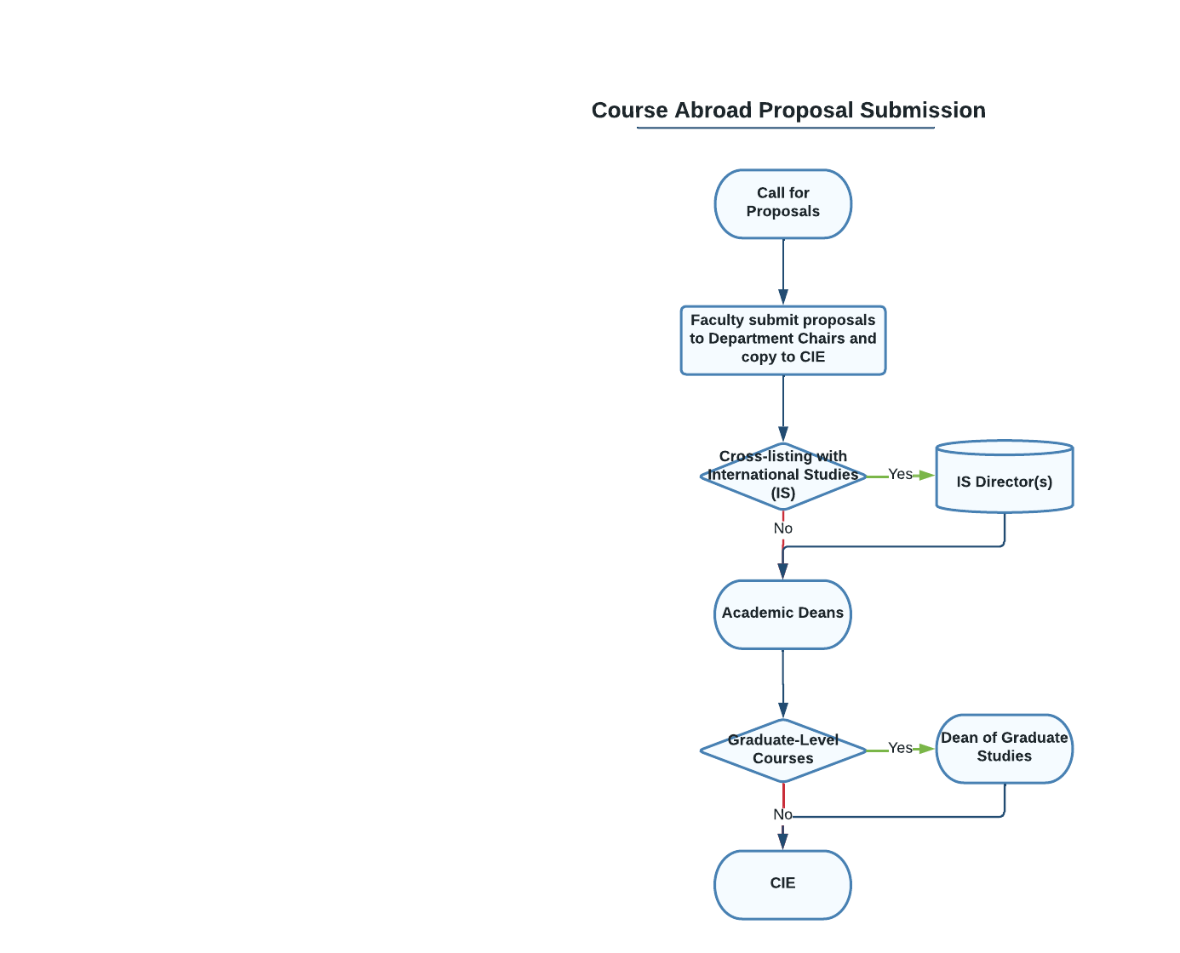

Note: Faculty directors submit final itineraries to CIE according to the following schedule:

• Final itineraries for winter courses are due June 1.
• Final itineraries for spring courses are due September 1.
• Final itineraries for summer courses are due December1.

II. CIE’S FINAL APPROVAL

CIE approval will be based on past program success, the volume of proposals received for a particular country or world region, the overall number of programs proposed, and the United States Department of State Travel Advisories/Warnings and the Center for Disease Control (CDC) guidelines.

Please also note that CIE is responsible for overseeing all administrative aspects of the Courses Abroad programs. This includes, but is not limited to: facilitating the Course Abroad approval process; making final decisions regarding program budgets and all disbursements; assisting faculty members with promoting their program to students; meeting with participating faculty members to determine course-program costs and establish individual group as well as individual student budgets; developing application and scholarship forms; assessing fees on student accounts; generating promotional materials to advertise the Courses Abroad programs; coordinating internal support systems with the offices of the Bursar, Financial Aid, Purchasing, and Accounts Payable; managing risk, health, and emergency issues; and awarding study abroad scholarships.

III. LEARNING OUTCOMES

Faculty who teach Course Abroad are expected to identify and incorporate into their courses at least 4 of the following international/intercultural competencies:
International/Intercultural Competencies for CCSU Students
Developed by the Internationalization Laboratory - 2008
KNOWLEDGE
Students will be able to explain the complexity and interdependency of global events and issues by demonstrating:

  - Knowledge of world geography.
  - Knowledge of world history.
  - An understanding of diversity of values, beliefs, ideas, and world views.
  - An understanding of one’s own culture and its relationship to the rest of the world.
  - Knowledge of a foreign language.

ATTITUDES
Students will value and respect intercultural and global diversity by exhibiting:

2.1 Curiosity and openness toward new opportunities, ideas, and ways of thinking.
2.2 An awareness of ethnic and cultural differences.
2.3 The ability to examine issues objectively and without prejudice.
2.4 Appreciation for multiple perspectives.
2.5 An awareness of one’s own identity and culture.
SKILLS
Students will act as global citizens by:

3.1 Thinking critically and creatively and integrating knowledge of the world.
3.2 Communicating effectively, including using a foreign language, and interacting with
people from other cultures.
3.3 Coping with unfamiliar and challenging settings with resiliency.
3.4 Locating information and investigating issues about international topics.

Following the Course Abroad experience, faculty will be required to submit an evaluation of the learning outcomes achieved by the students. Separately, the Center for International Education will administer a post-program student survey to assess students’ views on achieving the stated international competencies.

IV. DEVELOPING A COURSE ABROAD SECTION

Faculty interested in developing a Course Abroad section are encouraged to begin by meeting with the CIE International Education Coordinator. Faculty should also consult with their department chair and/or colleagues to discuss plans and gain departmental support for the course offering. Once preliminary departmental approval has been obtained, the following questions should be considered as the Course Abroad is developed:

Students: (1) What evidence is there of student interest for the program? (2) How will the program be marketed? (3) What student populations, majors, and minors will be targeted for promotional activities?

Cultural/Logistical: (1) What activities/assignments will integrate students into the local community? (2) What support services are available to students on-site? (3) How will students be counseled to spend any free time safely?

Academic Criteria: (1) Are intended credit hours of the program appropriate for the program duration? (2) Are the resources and facilities available to the students adequate to achieve the academic goals?

V. STAFFING, REMUNERATION, AND INDEMNIFICATION

Eligibility to Teach/Expertise: Faculty who teach Course Abroad are expected to be familiar with the destination country. Fluency in the language of the country to be visited is recommended, but not required. To teach a Course Abroad, one must be a CCSU employee and be approved by the Department Chair and appropriate Dean for such instruction. Faculty who wish to team-teach a single Course Abroad must state such at the time of the original application; they may not change their designation later. All courses with more than one instructor, including team-taught courses, must demonstrate enrollments sufficient to cover costs for the entire program.

Responsibility: Leadership for a Course Abroad also assumes the commitment to follow University’s policies that pertain to academic, financial, and health/safety issues. Relevant policies will be reviewed/discussed in detail at the CIE Faculty orientation meeting.

Remuneration: Only CCSU employees may receive payment. No acquaintance, relative, or dependent of the instructor will be designated “chaperone” for the course or receive CCSU remuneration.

Travel commitment: Faculty leading a Course Abroad are required to travel with the entire group of students, to and from the international site. Once abroad, Faculty must remain in continual contact with the students throughout the program.

VI. COURSE ABROAD SCHEDULING MODELS

• Three-week winter session course with winter travel component: The course and travel component occur during winter session. Students pay winter session course tuition and the cost of the travel program. Faculty receive winter session compensation for teaching the course.

• Full-semester spring course with spring break travel component: The course is offered as a full-semester course. The travel component occurs during spring break. The course is part of the faculty member’s spring load. Full-time students include the course in their spring schedule, subject to the excess credit policy. Additionally, students will pay the cost of the travel program.

• Full-semester spring course with travel component occurring in early summer. The faculty offer a full-semester spring course as part of their spring course load. Students register for the spring course, but faculty do not enter any grade during the spring grade reporting period, resulting in a grade of NR (Not Recorded). Travel abroad occurs during the month of May. Upon return to the U.S., students complete course assignments and the faculty member submits grades to the Registrar. The main benefit of this model is that full- time students can include the course in their spring schedule (subject to the excess credit policy) and not incur summer session tuition in addition to the cost of the travel component. However, since no summer session tuition is paid, faculty do not receive summer session compensation.

• Five-week summer course with summer travel component: Both the course and the travel components occur during Summer Session. Students pay Summer Session course tuition and the cost of the travel program. Faculty receive Summer Session compensation for teaching the course.
Important Programing Notes:
- Faculty must specify the selected Course Abroad model at the time the proposal is submitted. The travel component of a Course Abroad program can be scheduled in Winter Session (late December to January), over Spring Break and during the summer months (mid-May through August).

- Winter Session and Summer Course Abroad are scheduled to coincide with the dates of the University’s scheduled sessions. The inclusive dates of the travel program must fall within the official dates of the semester/session. The sponsoring academic department(s) submit course listings and faculty appointment forms as they would for any winter or summer session course offered on the CCSU campus. The Registrar’s Office creates course sections and enrolls students, and the Human Resources Office calculates compensation for faculty according to the agreed upon formula. Winter and summer session courses will require a minimum of 6 students for the course to run, however more participants may be required to cover the travel costs.

- Spring Course Abroad are a popular option for full-time students, primarily because there is not a separate tuition charge, as is the case with winter and summer session programs. A Course Abroad is part of the faculty member’s full-time teaching load and, therefore, must meet the School’s minimum enrollment level. Faculty wishing to offer a Course Abroad program in the spring must discuss the program with their chair and/or dean, who can inform them of the minimum enrollment requirement for their spring teaching load. Each school may require different minimum enrollment levels for reasons such as instructional costs, accreditation requirements, load/overload issues, or other issues.

- All students who enroll in a spring semester course that features a Course Abroad component are required to participate in the Course Abroad component to be able to receive credit for the full-semester course. Close coordination between the CIE and Course Abroad faculty ‘directors’ is necessary. Reconciliation of the class roster and the CIE travel program participant roster must be conducted in a timely manner, and no later than the end of the CIE registration deadline. A final decision regarding “sufficient” enrollment shall be made during the week following the CIE registration deadline, in consultation with the faculty director(s) and appropriate Dean.

- No Course Abroad shall consist of 45 contact hours concentrated in a one-week travel component.

- In selecting the Course Abroad model, faculty are encouraged to consider the location and time of year carefully. Travel costs to most locations can be significantly different depending on the time of year. Because cost is an important factor, faculty are encouraged to consult the CIE or other resources to determine when travel to the selected country or region is most economical.

VII. COURSE LOAD, CONTACT HOURS, AND SYLLABI

- Creation of Course Sections in Banner: The academic department has complete authority over the academic course(s) associated with a course abroad. It is the responsibility of the academic department to submit the appropriate paperwork to create the course section(s) in Banner, assign faculty load, and/or initiate Winter Session or Summer Session faculty compensation forms. The Program Coordinator of the International Studies Program acts as a department chair in the establishment of International Studies courses and submission of the relevant faculty salary forms.

- Contact Hours: The credit load of a Course Abroad must meet the academic standards of the instructor’s Department/School and the guidelines for contact hours for all CCSU courses. A contact hour is generally defined as time spent in an activity that engages students in the learning objective(s) of the course. This can include lectures, site visits, excursions, discussions, student presentations and the like. It is important to differentiate between time spent in travel and time spent engaged in the pursuit of the academic objective of the course. When planning their Course Abroad syllabi, faculty should be mindful of the minimum standards for academic credit; that is:

- Courses for 3 credits: 45 contact hours
- Courses for 6 credits: 90 contact hours

- Course Load: Per CCSU regulations, the maximum course load during winter and summer is as follows:

    - Winter Session: the maximum course load in winter session is 4 credits.
    - Summer Session: the maximum course load is 7 credits during each five-week summer session and 4 credits during the post-session.

An instructor who teaches two (2) separate courses (not cross-listed) within the Course Abroad format must show the equivalent of 90 contact hours spent in academic instruction while abroad and present an itinerary of at least four (4) weeks duration to accommodate the number of hours. Course abroad that include a study abroad component less than two weeks in duration must clearly identify a schedule of on-campus contact hours that occur prior to and after the study abroad component to ensure that the minimum contact hour requirements stated above have been met. Faculty who have questions about course load should consult their Dean for details.

- Team-Taught Courses: If two or more faculty are collaborating to offer a Course Abroad, each faculty member must enroll a sufficient number of students. Faculty who have questions about the definition of team-teaching and the precise minimum number of students required should consult their Dean’s office. A clear contingency plan must be included in the proposal, indicating whether part or all of the Course Abroad program will be cancelled, if one, but not all, faculty member enrolls the required minimum number of students. Team-taught Courses must follow the same Course Abroad model and travel itinerary.

- Cross-Listed Courses: Two courses at the same level (undergraduate) which share common lectures may be cross-listed. Faculty should clearly indicate cross-listings on the Course Abroad Proposal Form.

- Linked Courses: A “link” course is a graduate course which may share lectures with a specific advanced undergraduate (400-level) course on the same topic. These courses may be electives. Each of these courses will have different numbers, titles, syllabi, and requirements. Undergraduate link courses must not have graduate credit. Faculty should clearly indicate linked courses on the Course Abroad Proposal Form.

- Bridged Courses: A “bridge” course is an entry-level graduate course which may share lectures with a specific advanced undergraduate (400-level) capstone course that is integral to each program (undergraduate and graduate). Each course will have a different number/syllabus and requirements. Faculty should clearly indicate bridged courses on the Course Abroad Proposal Form.

Courses being proposed as cross-listed, linked, or bridged, must be listed that way in the Course Catalog.

- Course Syllabi: A syllabus for each course offered in conjunction with the Course Abroad program must be submitted with the Course Abroad proposal. A separate syllabus is required for all graduate courses.

VIII. MISCELLANEOUS COURSE ABROAD DESIGN AND IMPLEMENTATION PARTICULARS

PROGRAM ITINERARIES

Itinerary: As travel itineraries are developed, faculty are encouraged to pay close attention to the length and complexity of the proposed itinerary, keeping in mind that these factors will contribute to the overall cost of the Course Abroad program

Itinerary Modification: The CIE staff will make every effort to procure travel services that are aligned with the program goals and objectives stated in the Course Abroad Proposal. The CIE reserves the right to modify proposed itineraries when concerns about cost, health and/or safety and security arise. Please be sure your dates are as accurate as possible. The CIE will start making travel arrangements as soon as feasible in order to plan the budget. It will be difficult to alter the dates once travel arrangements have been secured.

Site visits: Site visits can be critical to the objective of a Course Abroad. Significant thought should be devoted to how site visits will be structured, when they should be scheduled, and how the site visit will further the program’s learning objectives and community engagement goals.

FINANCIAL POLICIES

Budgets, vendors, contracts, fees, and penalties: As a State institution, all CCSU programs are subject to the strict financial regulations of the State of Connecticut. In all cases, the final decision regarding the budget and all purchases on behalf of the Course Abroad will be made by the CIE in accordance with State of Connecticut policies.

Deadlines/Course Cancellation: The CIE generally has deadlines with vendors aligned with the program registration deadlines. As a matter of policy, please note:

- Registration deadlines for under enrolled programs will not be extended beyond the original advertised date.

- During the next 15 days following the advertised registration deadline, any student desiring to submit a registration form will be charged a $100 late fee per day, up-to $1,500 -if 15 days late.

- The CIE reserves the right to cancel programs that do not enroll sufficient students to cover all costs, and where a restructured program is not possible. Prior to any cancelation, CIE will consult with the faculty in charge of the Course in question

This policy will be clearly stated on the program registration form as well as the CIE website and printed marketing materials.

Student scholarships: The CIE has limited funds for Course Abroad scholarships. The Center also maintains a listing of numerous external funding sources for students. Faculty are urged to send interested students to the CIE for all scholarship and funding information. Since student financial assistance is not guaranteed, faculty are urged to plan their Course Abroad program in a cost-efficient manner that enables as many students as possible to enroll.

PARTICIPANTS

Registration: Student complete a Course Abroad Registration Form online at the CIE’s website (www.ccsu.edu/cie) in a timely manner. The cost of the course tuition is not included in the Course Abroad fee charged by the CIE.

Course Registration and Tuition and Fees: Course tuition and fees are not included in the posted price of a Course Abroad program. Although students register for the travel program in the CIE, they must take the necessary steps to register separately for courses and pay tuition. All students register for coursework according to the Registrar’s normal course registration process (web and in-person registration happen at different times throughout the academic year). All students pay tuition and course fees in the Bursar’s Office or through their Pipeline account. Dropping an academic course does not constitute proper withdrawal from a Course Abroad program.

Late/dual-enrolment: Under no circumstances may a student be simultaneously enrolled in a full- semester study abroad program and a Course Abroad program or join a Course Abroad program already in progress.

Chaperones: The ideal faculty-to-student ratio in a Course Abroad program is 1:14. When larger enrollments occur and the program budget permits, CIE may assign an additional chaperone with no teaching responsibilities.
Non-CCSU Students and Faculty Guests: Students from other CSCU campuses, colleges, and universities outside the CSCU system and faculty guests may enroll in CCSU Course Abroad and pay the full program price to CCSU.

Non-Credit Participation: Anyone who wishes to participate in a course abroad program on a non-credit basis must get permission from the faculty and pay an additional $300.

HEALTH, SAFETY, AND EMERGENCY PROCEDURES

Emergency Response Policy and Procedures for CCSU Study Abroad Programs/Incident Report Form: Faculty who teach Course Abroad also assume “first-responder” oversight responsibility for the students who travel with them. The published procedures that pertain to emergencies and incident reporting requirements are provided by the CIE at the required orientation meeting and are always available on the CIE website. All CCSU faculty, students, and staff who participate in a Course Abroad are covered for medical evacuation/repatriation of remains insurance through either CCSU/Aetna student health insurance or On-Call International insurance for faculty.

Comprehensive Travel Insurance/Trip Cancellation/Interruption Insurance – Enrollment in a comprehensive trip cancellation/interruption insurance policy occurs at the discretion of every Course Abroad participant. The cost of such insurance will be borne personally and is not included in the Course Abroad Travel Program fee. Participants are free to research, select, and enroll in any policy of their choosing.

Locations of hospitals, police stations, and embassies: Course Abroad faculty directors are expected to be familiar with the location of facilities that they or their students may need in the event of an emergency or evacuation notice. These include the locations and phone numbers of nearby clinics/hospitals, police stations, and embassies.

Risk avoidance: Faculty who lead Course Abroad are reminded that the CIE prohibits travel to locations where the U. S. Department of State has issued a level 3 (Reconsider Travel) or level 4 (Do Not Travel) Travel Advisory. The University further forbids engagement in any activities that put the students and the program in general at risk. The purchase of alcohol with State funds is also strictly prohibited.

MARKETING AND PROMOTION

It is very important that faculty market their programs to students as early as possible. Although the CIE will aggressively market Course Abroad in numerous ways (e.g. Course Abroad Catalogs, Fairs, information sessions, posters, etc.) we could not possibly see as many students as faculty throughout the course of a semester. It is the instructors themselves that are most influential and successful recruiters for the programs.

ACCESSIBILITY

AA/EEO: CCSU is committed to a policy of nondiscrimination in education and employment. No person shall be discriminated against in terms and conditions of employment, personnel practices, or access to or participation in programs, services, and activities with regard to: age; ancestry, color; gender identity and expression; intellectual disability; learning disability; mental disability; physical disability; marital status, national origin; race; religious creed; sex, including pregnancy, transgender status, sexual harassment and sexual assault; sexual orientation; or any other status protected by federal or state laws. This policy is applicable to all employment practices, admission of students, programs and services to students, faculty, staff, and the community. This policy is equally applicable to off-campus programs sponsored by Central Connecticut State University, such as the Course Abroad program.

Prerequisites: The basis upon which a student may be denied enrollment in a Course Abroad program includes, but is not limited to, failure to maintain good academic standing, inadequate course prerequisites, or evidence of pending judicial proceedings.

ACCOMMODATION

Any student wishing to assert a disability that requires accommodation must submit supporting documentation from the appropriate professional(s) to the Office for Student Disability Services. Students must register with the Office of Student Disability Services at least ninety (90) days prior to the program’s departure date. For more information about this process, contact the Office of Student Disability Services in Willard-DiLoreto Hall, Room W201 or visit their website at http://www.ccsu.edu/sds/index.html.

ORIENTATION PROGRAMS

By Faculty: It is expected that the faculty conducting Course Abroad programs will hold several group meetings prior to departure in order to review specific program objectives and academic requirements and to share additional information on the academic course(s) and destination(s) to be visited.

For Faculty: Leadership of a Course Abroad also assumes the commitment to follow University policies that pertain to academic, financial, and health/safety issues. These policies are contained in this document and will be provided and discussed at the CIE orientation meeting, which is required for all Course Abroad faculty.

For Students: The CIE will organize a pre-departure orientation program during one of the pre-departure class times. The agenda for the CIE orientation program generally includes reviewing the University’s risk management policies and recommending best practices, discussing travel itineraries, distributing travel documents (including the comprehensive Course Abroad Survival Guide, and answering questions from participants and faculty).

ASSESSMENT

Students: The CIE will require a Course Abroad assessment survey of every participant within two weeks of the program’s conclusion.

PROGRAM CANCELLATION, WITHDRAWAL, AND TERMINATION

Cancellation by CCSU due to Low Enrollment:

Since academic departments/schools own the academic course offerings associated with Course Abroad and the Center for International Education is fiscally responsible for the travel component, these two aspects must be considered simultaneously when making the decision to offer or cancel a course abroad. The decision to offer the course section is the responsibility of the academic dean, working with the academic department and Registrar’s Office. The decision to offer or cancel the travel program based on enrollment levels rests with the Center for International Education and must be made in relation to the actions of the academic dean. Therefore, close communication between the academic dean’s office and the Center for International Education is required. The cost of the travel component of the program is based on a minimum number of students registering for the program. When there are not enough students enrolled to cover the cost of the ‘abroad’ portion of the program, the program may be cancelled.

Cancellation by CCSU due to Risk/Safety Concerns:

The Director of the Center for International Education, in consultation with the Course Abroad faculty, may re-route or cancel a Course Abroad program prior to departure, if the destination location is determined to be unsafe for student and faculty travel. Resources to be used in monitoring situations and formulating recommendations include the Consular Information Sheets, Travel Advisories, and Travel Warnings issued by the U.S. Department of State, the CDC, newspaper reports, and independent travel advisory companies.

If CCSU cancels a program because of safety concerns, students will be provided a full refund of all travel and course fees paid. Any cancellation penalties imposed by travel service providers will be paid by the University.

Withdrawal by Students/Participants – Travel Program:

If a student must cancel participation in a Course Abroad travel program, s/he must do so in writing to the International Education Coordinator as soon as such decision is made. Dropping an academic course does not constitute proper withdrawal from a Course Abroad program.
The Course Abroad Cancellation Policy is calendar-based and customized to the dates of travel for each Course Abroad
Program. The cancellation policy for each program will be stated on the program’s Registration Form.

Withdrawal by Students – Academic Course(s):

The normal University course withdrawal policies for full- and part-time students apply to the academic courses associated with all Course Abroad programs.

Termination:

Under certain circumstances, it may become necessary to terminate a student’s participation in a Course Abroad program either prior to or after departure. Incidents that may warrant a student’s termination and withdrawal from a Course Abroad program may include, but are not limited to: (1) Failure to submit required documentation to the CIE; (2) Failure to attend required pre-departure meetings; (3) Violation of host country laws; (4) Conduct that violates the CCSU Code of Conduct. (5) Conduct considered to be harmful to the student or others; (6) Failure to meet academic standards; (6) Physical or mental incapacitation; (7) Engaging in unauthorized income-producing activities inconsistent with the purpose and best interest of the program.

Note: Faculty will be informed of the process to terminate a student from a Course Abroad Program at the Faculty Pre- Departure Orientation meeting. In summary, the process has 3 steps: (1) verbal warning, (2) written warning in the form of a Letter of Warning (provided by CIE), and (3) termination, if offensive behavior continues after the Letter of Warning has been issued. Faculty considering terminating a student’s enrollment in a Course Abroad program are requested to confer with the International Education Coordinator, Zongxiang Mei, via email (zongxiang.mei@ccsu.edu) or by telephone (860) 832-2043 or fax (860) 832-2047, with their academic dean, and CCSU’s Office of Student Conduct or (860) 832-1667. Caution should be taken to ensure that due process is afforded students in all instances. Once dismissed from a course abroad, the student loses access to all group travel arrangements, except for the return airline ticket. The CIE will bill the student (via their Pipeline account) for any additional costs associated with their termination. Caution should be taken to ensure that due process is afforded students in all instances.

Students are informed of the termination clause during the pre-departure orientation and also via the Statement of Due Warning and Assumption of Risk form, which reads “…this is a group program, and group standards must be observed. [The student] agrees that the University and/or the course director(s) shall have the right to terminate [the student’s] enrollment for failure to maintain these standards, or for actions or conduct which the University and/or course director(s) consider(s) to be detrimental to or incompatible with the interest, harmony, comfort, or welfare of the course and group as a whole. [The student is] aware that all facets of the University’s Student Code of Conduct apply to this program.”

PLANNING RESOURCES

Links to Safety Related Web Sites:

• http://travel.state.gov - Bureau of Consular Affairs, US Department of State, Travel Warnings/Public
Announcements/Consular Information

• http://www.state.gov/travel/ - Travel and Living Abroad site, providing emergencies and warnings, passport and visa info, living abroad info, etc.

• http://www.cdc.gov/travel - Centers for Disease Control - Travelers' Health

• Tips for Traveling Abroad – Traveler’s Check List published by the U.S. State Department

• "Crisis Abroad -- What the State Department Does" - State Department during a crisis overseas

CIE STAFF CONTACTS FOR THE COURSE ABROAD PROGRAM:
Dr. Zongxiang Mei
International Education Coordinator
Center for International Education
860-832-2043
zongxiang.mei@ccsu.edu

