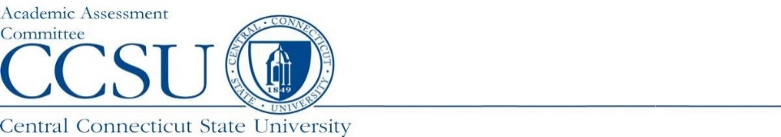
Report Submission Instructions for Assessment Reporting
Office of Institutional Research and Assessment (OIRA)

Instructions
- Assessment Reports are due the last Friday in September each year; early submissions are always appreciated.
- Use only the forms provided on the Assessment website page; this supports consistent data collection procedures.
- For Full Reports and New Program Reports, please also include the corresponding Summary Sheet.
- Be sure to complete all relevant sections of the report.
- Include the program, degree level(s), academic year, report completion date, name of report preparer; choose one type of program structure: accredited, non-accredited, or combination (accredited with a non-accredited component)
- If accredited, include accreditation agency, and date the next self-study is due to the accreditation agency.
- Follow FERPA guidelines; identifiable information for students should not be included in any section of the report.
- A separate report must be submitted for each respective academic program, except for embedded programs.
- For Accredited Programs: During the year of accreditation review, provide a copy of the Program Self-Study submitted to the agency and the corresponding Feedback Letter.

Report Forms
All certificate and degree programs are required to be assessed by New England Commission on Higher Education (NECHE) to ensure educational quality. Our Assessment process ensures we are compliant with NECHE and the CSCU Board of Regents (BOR). Reporting requirements are determined by accreditation/non-accreditation status. Please choose from the options below:

Externally Accredited Programs Only:
- Effective as of AY2019-20, programs accredited by an outside agency no longer need to complete a Full or Interim assessment reports; instead, a Summary report submission is required every year.
- In the year the Program Self Study is due to the accreditation agency, a copy of the Self Study must be submitted to the Academic Assessment Committee (AAC) through the Office of Institutional Research and Assessment (OIRA). Please send the self-study to Martie Kaczmarek, Assessment Coordinator at mkaczmarek@ccsu.edu.
- Upon receipt of the accreditation agency Feedback Letter, a copy must be submitted to the AAC through OIRA to Martie Kaczmarek, Assessment Coordinator at mkaczmarek@ccsu.edu.

Non-Externally Accredited Programs Only:
- Assessment reporting is on a five-year cycle; a Full report is due in Year 1, a Summary report in Year 2 (the same year the Program Review self-study is submitted), followed by Interim Reports in Years 3, 4, and 5.
- Certificate programs considered embedded within a degree program do not need to be reported on separately.

Combination Programs: Accredited with Non-Accredited Component(s):
- Programs that have both an accredited and non-accredited component(s) will continue to report on a five-year cycle in order to provide the required assessment documentation for the non-accredited component.
- Follow the requirements in the above section for Non-Externally Accredited Programs.

Please review the Report Calendar on our OIRA website for current report submission requirements, including which certificate programs are embedded.

Submission of Reports
Please submit all reports via our new Assessment Report Portal: https://forms.office.com/r/bXkD7DKbtL

This new automated process will immediately notify Martie Kaczmarek, Assessment Coordinator, and upload the report to our website.
NOTE: Please submit all reports in a PDF format.

Questions?
Please contact Martie Kaczmarek, Assessment Coordinator, at mkaczmarek@ccsu.edu or ext.22304.

