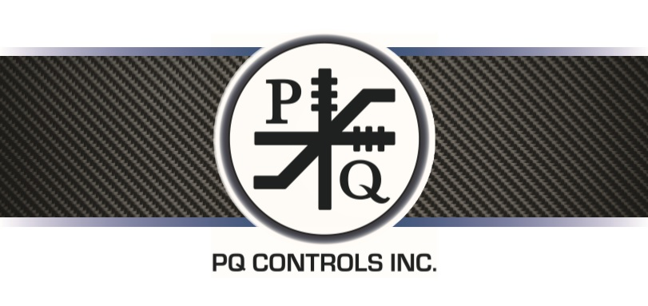

**P-Q Controls has been an industry leader in the outdoor/off-highway controls market for 50 years. We produce heavy duty joysticks and controls for mining, construction, aerial lifts, fire apparatus, forestry, and simulators.**

**We are looking for Student Interns to help our Assemblers and Final Test Technicians to fulfill our orders. This is an opportunity to have hands on experience that correlates to your education. Job functions include but not limited to:**

1. **Build electrical assemblies using p.c. boards or mounting plates, add potentiometers, cams, gears, etc.**
2. **Solder wires to switches according to the schematics**
3. **Mechanical assembly; build handles, add pins and bushings to housings, housing assemblies to hold various electrical assemblies, drill and tap cams**
4. **Cable assembly, build cables for various types of controllers, solder MS connectors, etc**

**Final Test Technician**

1. **Test completed controllers and/or electrical assemblies on appropriate test equipment**
2. **Record test data, serial numbers and report failure details**
3. **Test incoming repairs, diagnose problems and handle repair paperwork**

**No experience is needed. All Assembly and Final Test Technicians will be trained. However, attention to detail as well as good hand dexterity and hand/eye coordination is desired.**

**PQ Controls will work around any school schedule during the hours of 7:00am – 3:30pm, Monday – Friday.**

**If you are interested in joining our team, please email our Human Resources department at tsweetman@pqcontrols.com.**