**University Planning and Budget Committee Meeting of December 3, 2024   
1:45 pm – 3:00 pm, TEAMS  
Minutes**

J Jarrett, S Petras, M Bartone, D LaMay, A Cheema, Y Kirby, K Kostelis, W Henry, L Bucher, J Aguilar, J Whittemore, K Martin, S Kazar, Y Patterson

Minutes

1. Approval of Minutes – Approved
2. Announcements
   1. General
      1. Meeting with President Toro regarding the UPBC resolution
         1. Questions arose regarding metrics for decision making
         2. Faculty hiring documents were shared
         3. Some facilities planning does not go through UPBC and are made by the COO
         4. Data Dashboard will be presented to UPBS on 12/17
         5. Conversations will continue
   2. IPC
      1. Discussed UPBC Resolution
      2. ACT Framework Development – Concern over application and development of KPIs in terms of application to all institutions
   3. FPC
      1. Next meeting 12/19
3. Brief Reports
   1. CBCO
      1. Shared fund balances discussed
         1. 04/05 – reserved balances that can be used for food and housing repair needs
         2. 06 – Parking garages and mid campus debt service payments
         3. 08 – payment of 1.3 million per year is already set aside
         4. 10 – allowing to match grants; however, if grants do not materialize, the funds can be reallocated
      2. Best practices – 40% or 5 months of your operating costs in reserves
   2. Provost
      1. KPI
         1. Recommendations have been received from the schools
         2. A single recommendation will be put forward to faculty senate
      2. Faculty Request forms
         1. All deans are aware of their peers’ requests, offers perspectives on needs of the university as a whole
         2. No new faculty lines have come through UPBC recently b/c open lines, already funded, exist
            1. From 2017-2024 decrease in enrollment 15%, while decline in faculty lines was 8%
            2. Compared to NCHEMS, CCSU has a higher average of staff per 100 students, while staff is lower than the median

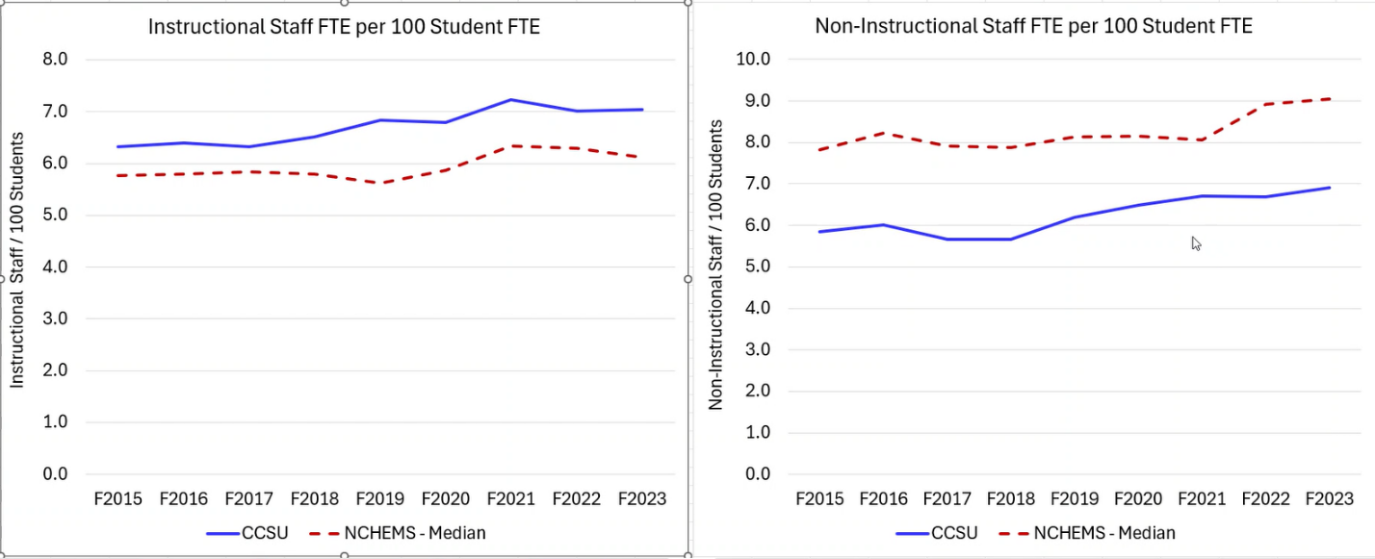

* + - * 1. Staff positions that were “created” were a mix of mandated, UPBC approved, title changes (clerical to management confidential or SUOAF)
        2. Of 20 positions, only 5 were new, requiring new funding
        3. FY 22 also featured 105 retirements
        4. Currently employ 412 full-time faculty, with other positions on hold, some at the request of the individual departments
        5. Creation of new roles cannot pull lines across unions, must come from salary savings
      1. OIRA
         1. Attending a NECHE conference with a new financial modeling

1. Executive Session
   1. Will be held at the end of each meeting to allow for free discuission
2. Adjornment – 3:00 pm